1. Spring Security provides 3 default implementations for UserDetailsManager (i).



1. **InMemoryUserDetailsManager**(c):
   1. When you’re doing some proof of concept or building some sample app.
2. **JdbcUserDetailsManager**(C):
   1. Most famous implementation.
   2. Production Grade Ready Implementation.
   3. It means if you provide Data Source to this implementation, this implementation has all the logic to load the Users from DS, creating them, deleting them, updating them etc.
3. **LdapUserDetailsManager**(C):
   1. If your app leverages LDAP Server for authentication and authorization, use it.
4. **Custom UserDetailsManager:**
   1. If not satisfied with those default provided implementation, then go to implement UserDetailsManager interface to create your own   
      UserDetailsManager class.

InMemoryUserDetailsManager

1. 
2. 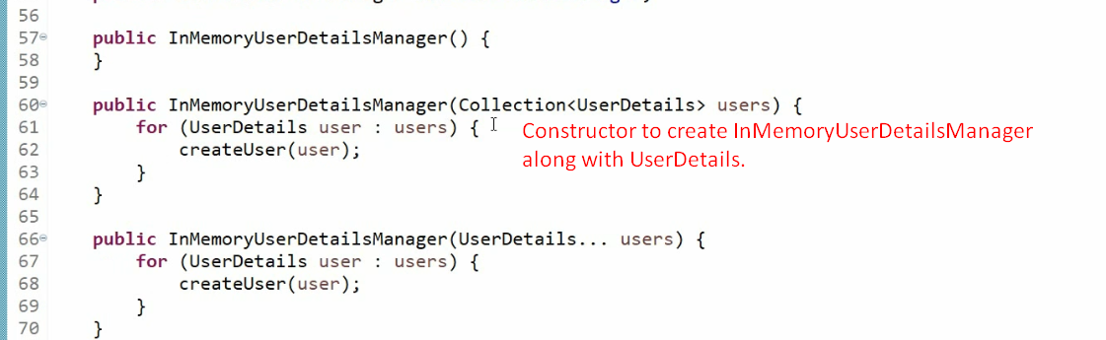
3. 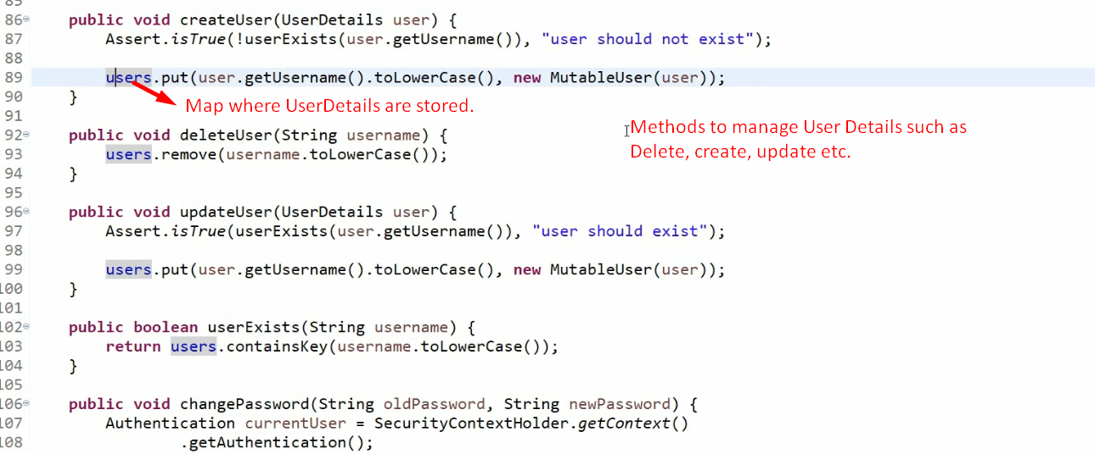
4. 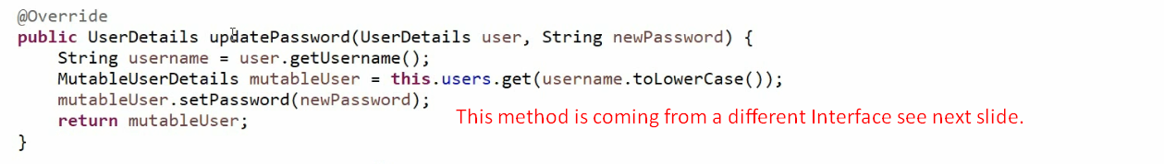
5. 
6. 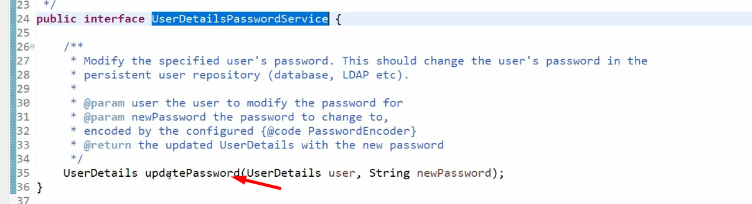
7. 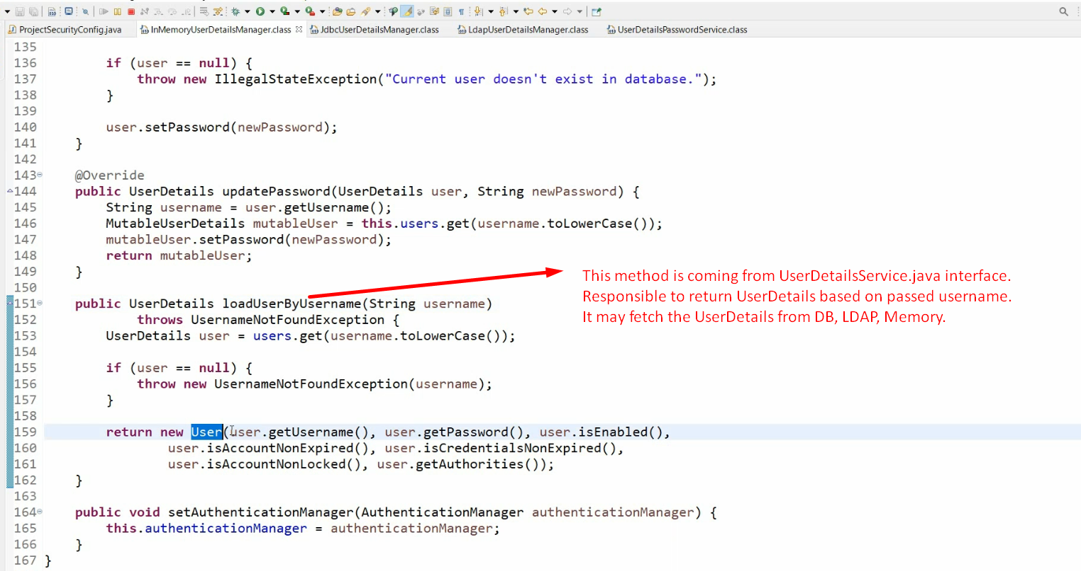
8. Let’s see the sample code written previously for this class to better understand InMemoryUserDetailsManager.
9. 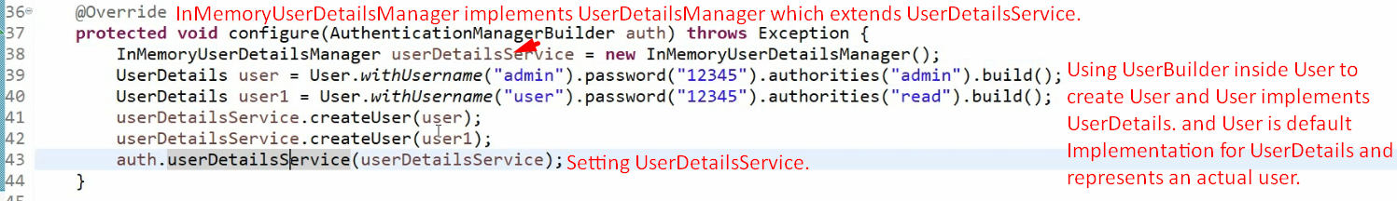
10. 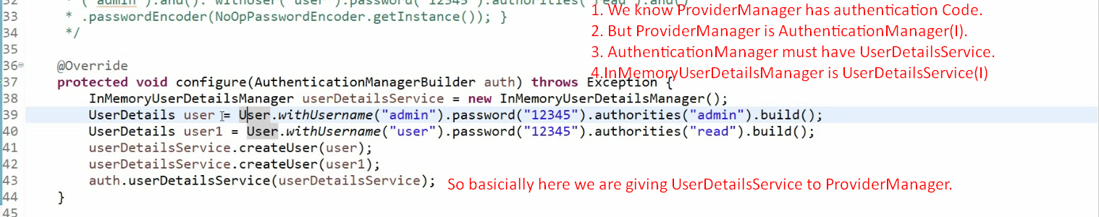
11. 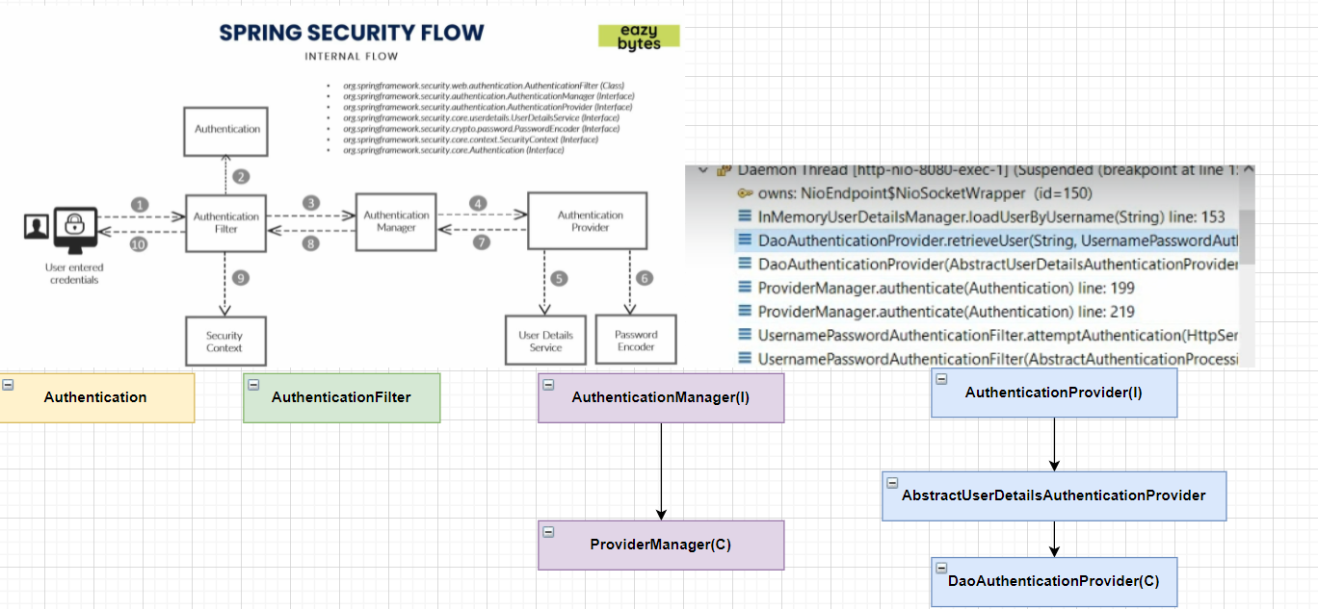
12. 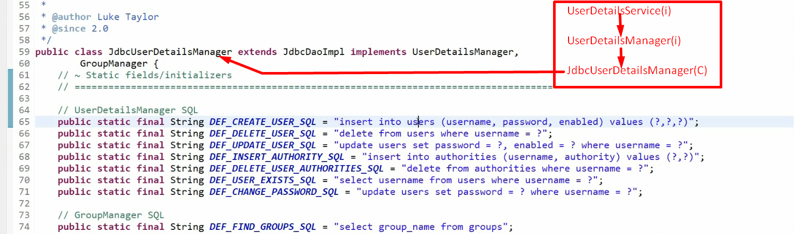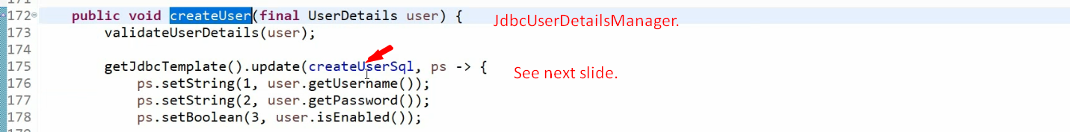
13. 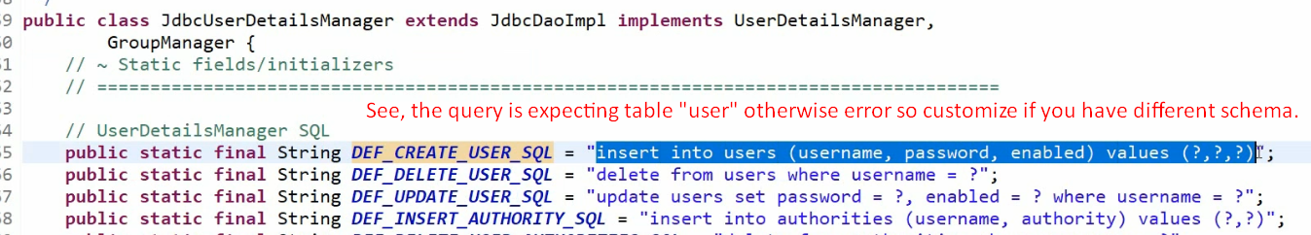
14. 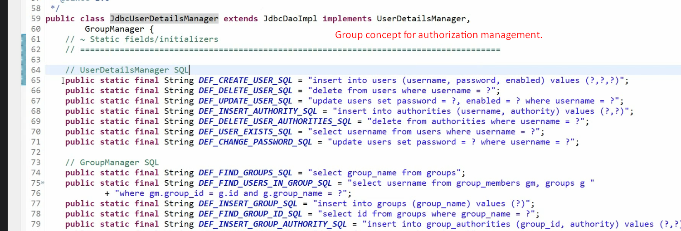
15. 